Q1.

mysql> SELECT Firstname, Lastname

FROM customers

WHERE CustomerID NOT IN (SELECT CustomerID FROM orders);



Q2.

mysql> select products.Productname,inventory.QuantityInStock

from products

join inventory on products.ProductID=inventory.ProductID;

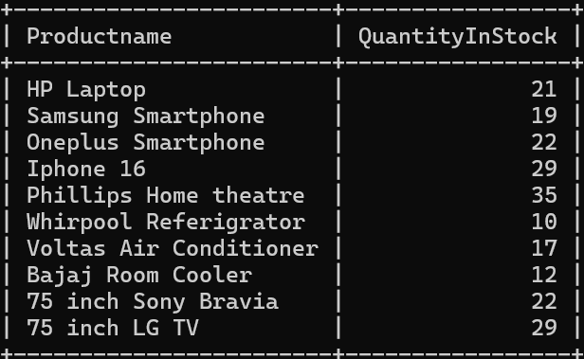

Q3.

mysql> select SUM(TotalAmount) as TotalRevenue

from orders;



Q5.

mysql> SELECT SUM(TotalAmount) AS CustomerRevenue

FROM orders

WHERE CustomerID = 3;



Q6.

mysql> SELECT customers.Firstname, customers.Lastname, COUNT(orders.OrderID) AS NumberOfOrders

FROM orders

JOIN customers ON orders.CustomerID = customers.CustomerID

GROUP BY customers.CustomerID

ORDER BY NumberOfOrders DESC ;



Q7.

mysql> SELECT products.Productname, (orderdetails.Quantity) AS TotalQuantity

FROM orderdetails

JOIN products ON orderdetails.ProductID = products.ProductID

ORDER BY TotalQuantity DESC;

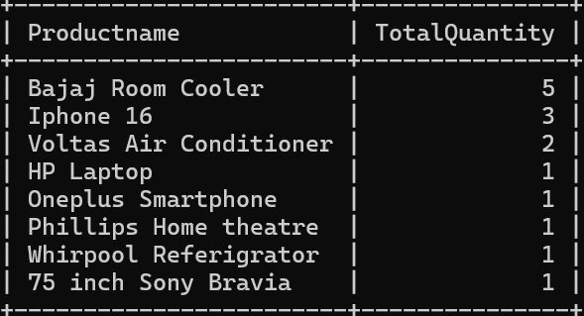

Q8.

mysql> SELECT customers.FirstName, customers.LastName, (orderdetails.Quantity \* products.Price) AS TotalSpent

FROM orderdetails

JOIN products ON orderdetails.ProductID = products.ProductID

JOIN orders ON orderdetails.OrderID = orders.OrderID

JOIN customers ON orders.CustomerID = customers.CustomerID

ORDER BY TotalSpent DESC

LIMIT 1;



Q9.

SELECT customers.FirstName, customers.LastName, AVG(orders.TotalAmount) AS AverageOrderValue

FROM orders

JOIN customers ON orders.CustomerID = customers.CustomerID

GROUP BY customers.CustomerID;

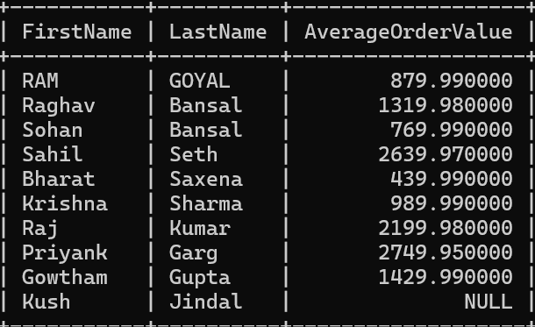

Q10.

mysql->SELECT customers.FirstName, customers.LastName, COUNT(orders.OrderID) AS TotalOrders

FROM Orders

JOIN customers ON orders.CustomerID = customers.CustomerID

GROUP BY customers.CustomerID;

